**TASK -1**

**Q1: Difference between HTTP1.1 and HTTP2**

**HTTP1.1:**

* HTTP/1.1, the first standardized version of HTTP, was introduced in 1997.
* It presented significant performance optimizations (over HTTP/0.9 and HTTP/1.0) and transformed the way requests and responses were exchanged between clients and servers.
* It allowed multiple requests/responses per TCP connection.
* The Upgrade header was used to indicate a preference from the client that made it possible to switch to a more preferred protocol if found appropriate by the server.
* It is relatively secure since it uses digest authentication, NTLM authentication.
* Headers are sent on every request leading to a lot of duplicate data being sent uncompressed across the wire.
* Expands on the caching support by using additional headers like cache-control, conditional headers like If-Match and by using entity tags
* Other features that reinforced its stability were introduced such as:
* pipelining (the second request is sent before the response to the first is adequately served)
* content negotiation (an exchange between client and server to determine the media type, it also provides the provision to serve different versions of a resource at the same URI)
* cache control (used to specify caching policies in both requests and responses)

**HTTP2:**

* At the beginning of 2010, Google introduced an experimental protocol, SPDY, which supported multiplexing (multiple requests/responses sent and received asynchronously over a single TCP connection) but as it gained traction IETF’s HTTP Working Group came up with HTTP/2 in 2015, which is based on the SPDY protocol.
* It introduces the concept of a server push where the server anticipates the resources that will be required by the client and pushes them prior to the client making requests.

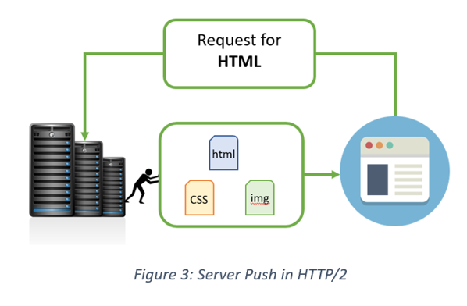

* Introduces the concept of multiplexing that interleaves the requests and responses without head-of-line blocking and does so over a single TCP connection.
* It is a binary protocol i.e. only binary commands in the form of 0s and 1s are transmitted over the wire. The binary framing layer divides the message into frames that are segregated based on their type – Data or Header. This feature greatly increases efficiency in terms of security, compression and multiplexing.
* HTTP/2 uses HPACK header compression algorithm that is resilient to attacks like CRIME and utilizes static Huffman encoding.